# Apply filters to SQL queries

## Project description

In this assignment, there are two tables named **employees** and **log_in_attempts** that through some instructions that will be explained, some SQL queries will be applied to them. The tables and their structure are explained in the “Table formats” document alongside this document.

## Retrieve after hours failed login attempts

You recently discovered a potential security incident that occurred after business hours. To investigate this, you need to query the **log_in_attempts** table and review after hours login activity. Use filters in SQL to create a query that identifies all failed login attempts that occurred after 18:00.

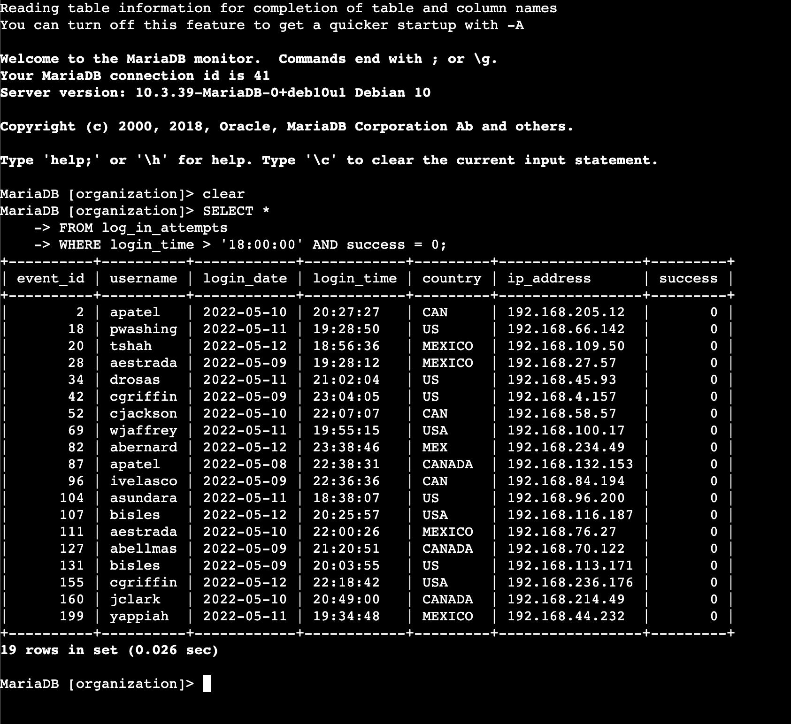

A query combining both instructions has performed using AND.

## Retrieve login attempts on specific dates

A suspicious event occurred on 2022-05-09. To investigate this event, you want to review all login attempts which occurred on this day and the day before. Use filters in SQL to create a query that identifies all login attempts that occurred on 2022-05-09 or 2022-05-08.

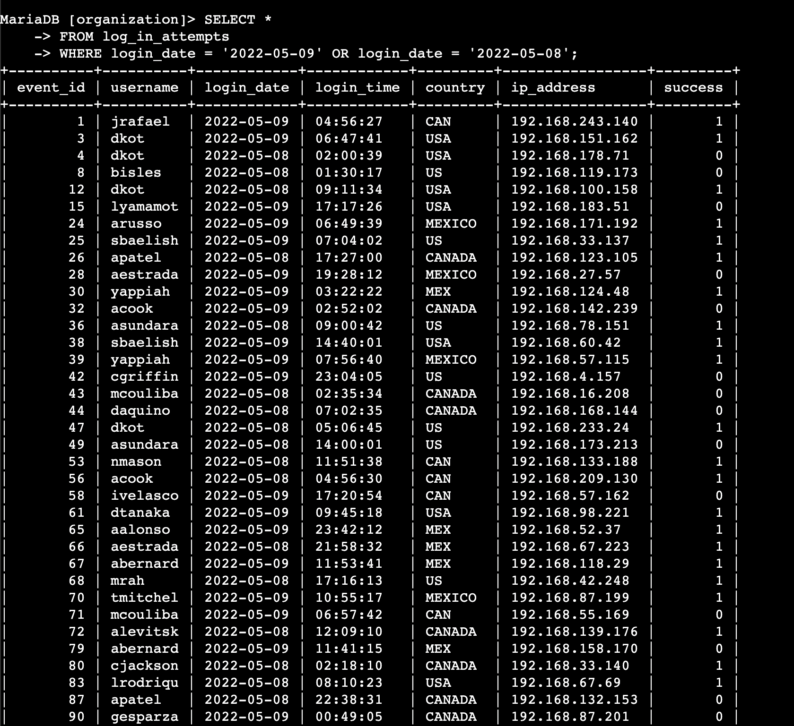

A query using OR is designed to retrieve the login attempts. The corresponding result table has 75 rows, all of which cannot be represented here.

## Retrieve login attempts outside of Mexico

There’s been suspicious activity with login attempts, but the team has determined that this activity didn't originate in Mexico. Now, you need to investigate login attempts that occurred outside of Mexico.

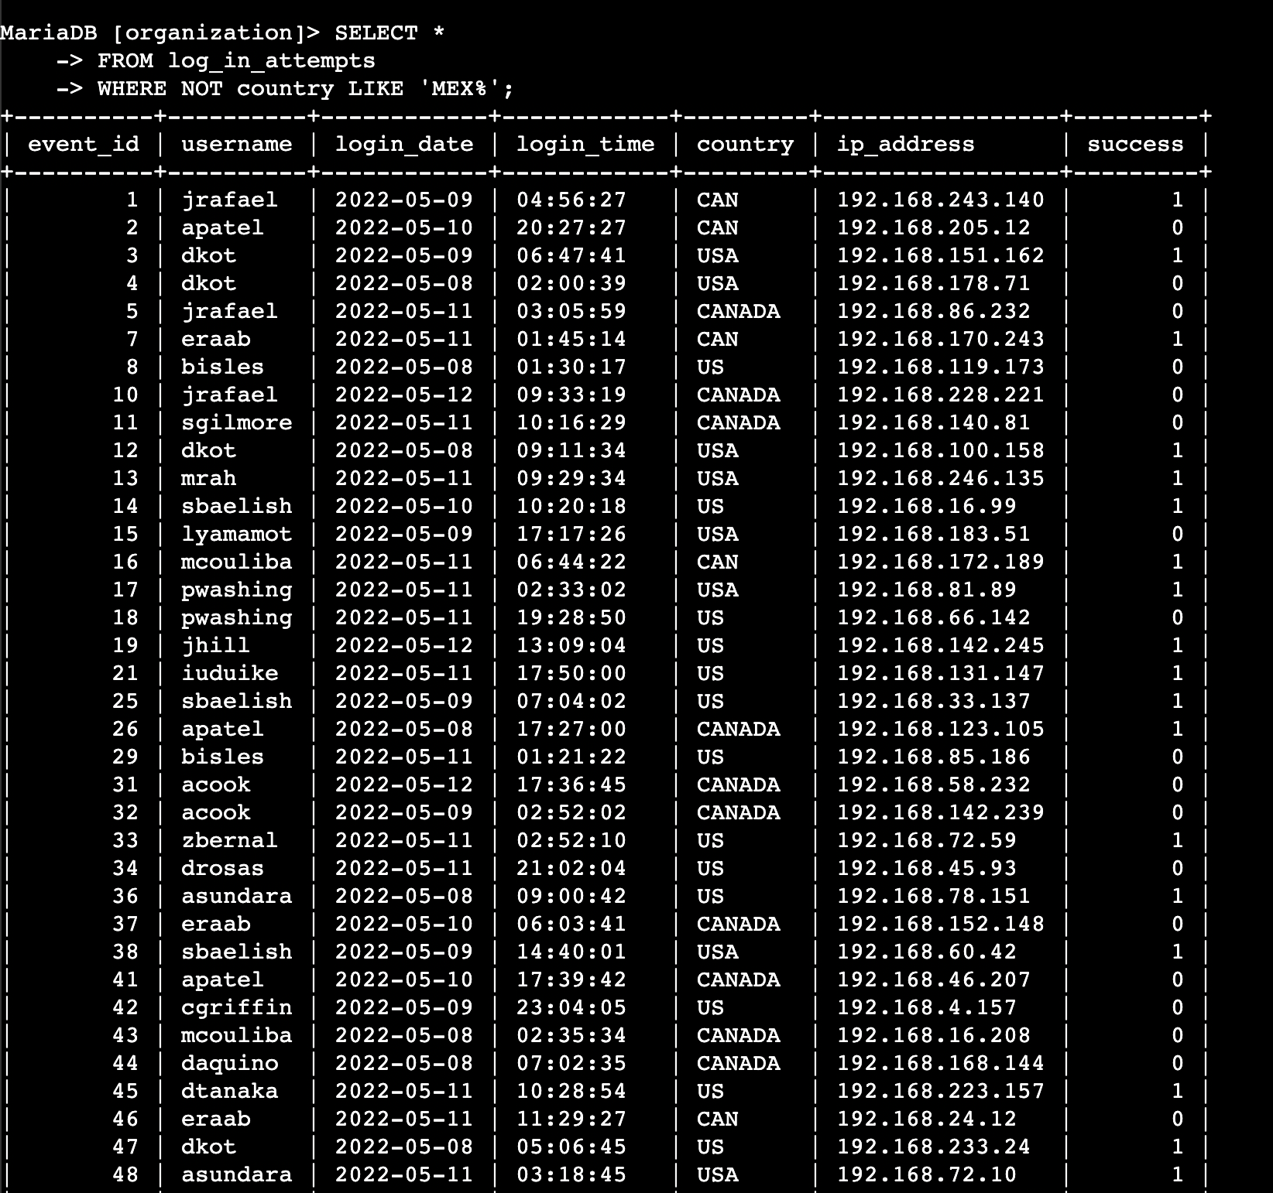

To investigate this, a query with the NOT keyword is used to exclude all login attempts outside of Mexico. The corresponding result table has 144 rows, all of which cannot be represented here.

## Retrieve employees in Marketing

Your team wants to perform security updates on specific employee machines in the Marketing department. You’re responsible for getting information on these employee machines and will need to query the **employees** table. Use filters in SQL to create a query that identifies all employees in the Marketing department for all offices in the East building.

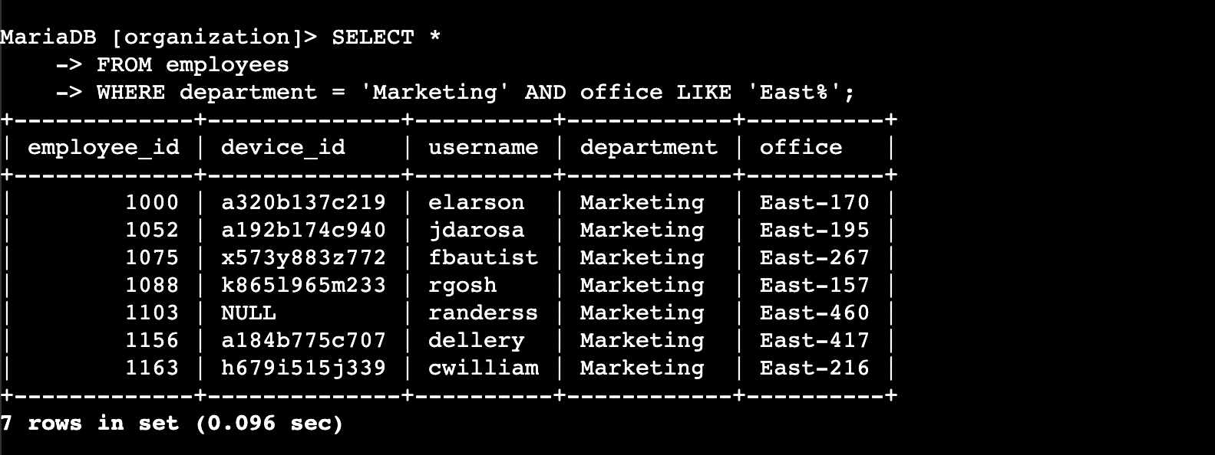

A query is designed to only include those employees who work in the Marketing and their offices are in the east building. There are only 7 employees with such specifications.

## Retrieve employees in Finance or Sales

Your team now needs to perform a different security update on machines for employees in the Sales and Finance departments.

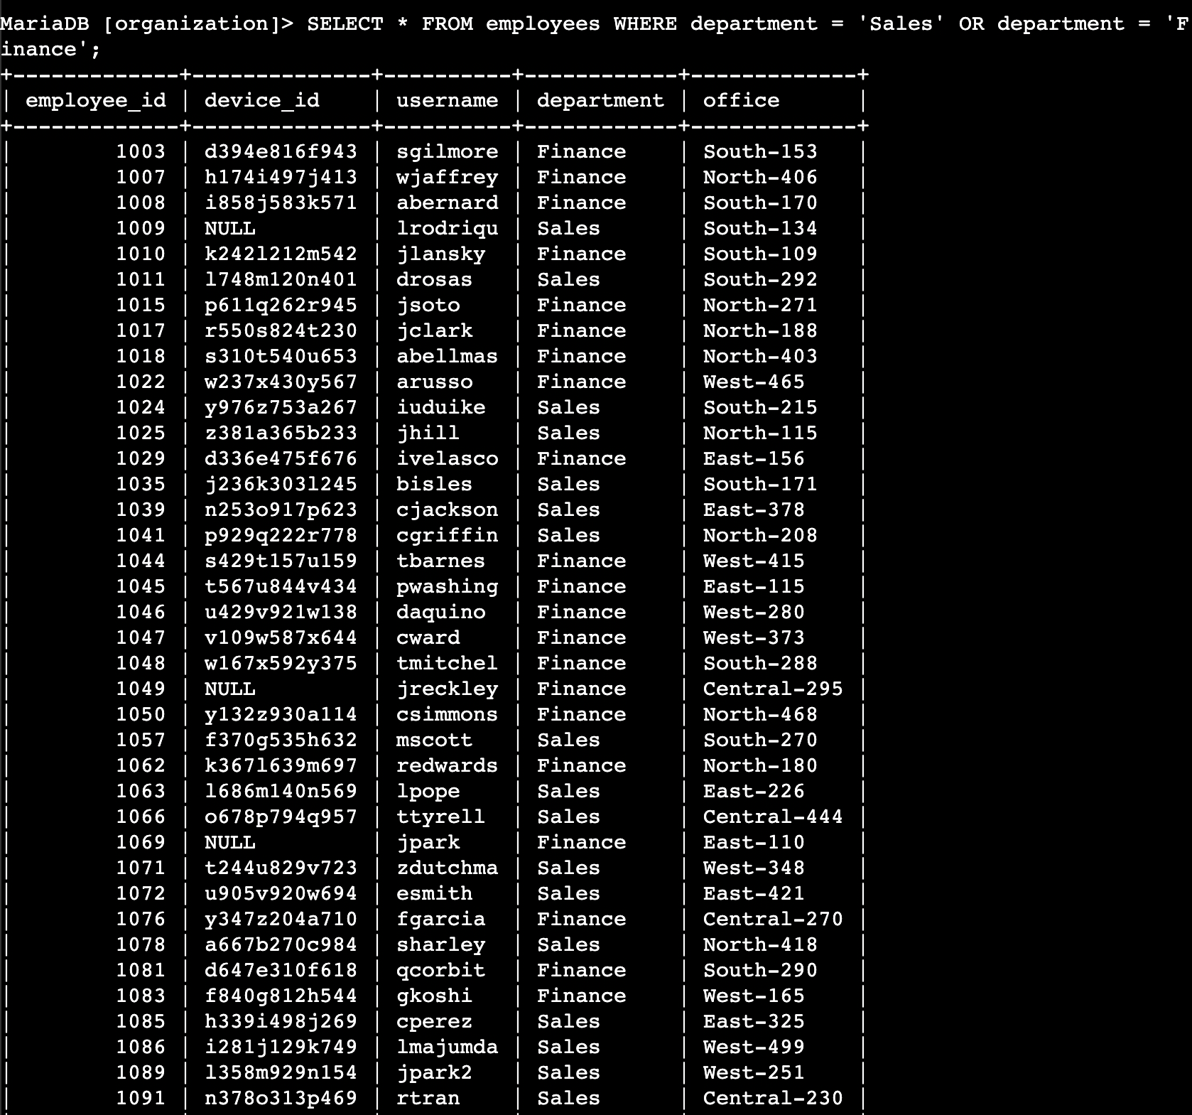

To retrieve a table excluding all other than those employees working in Sales or Finance, a query using OR is performed. The result table has 71 rows, all of which cannot be represented here.

## Retrieve all employees not in IT

Your team needs to make one more update to employee machines. The employees who are in the Information Technology department already had this update, but employees in all other departments need it.

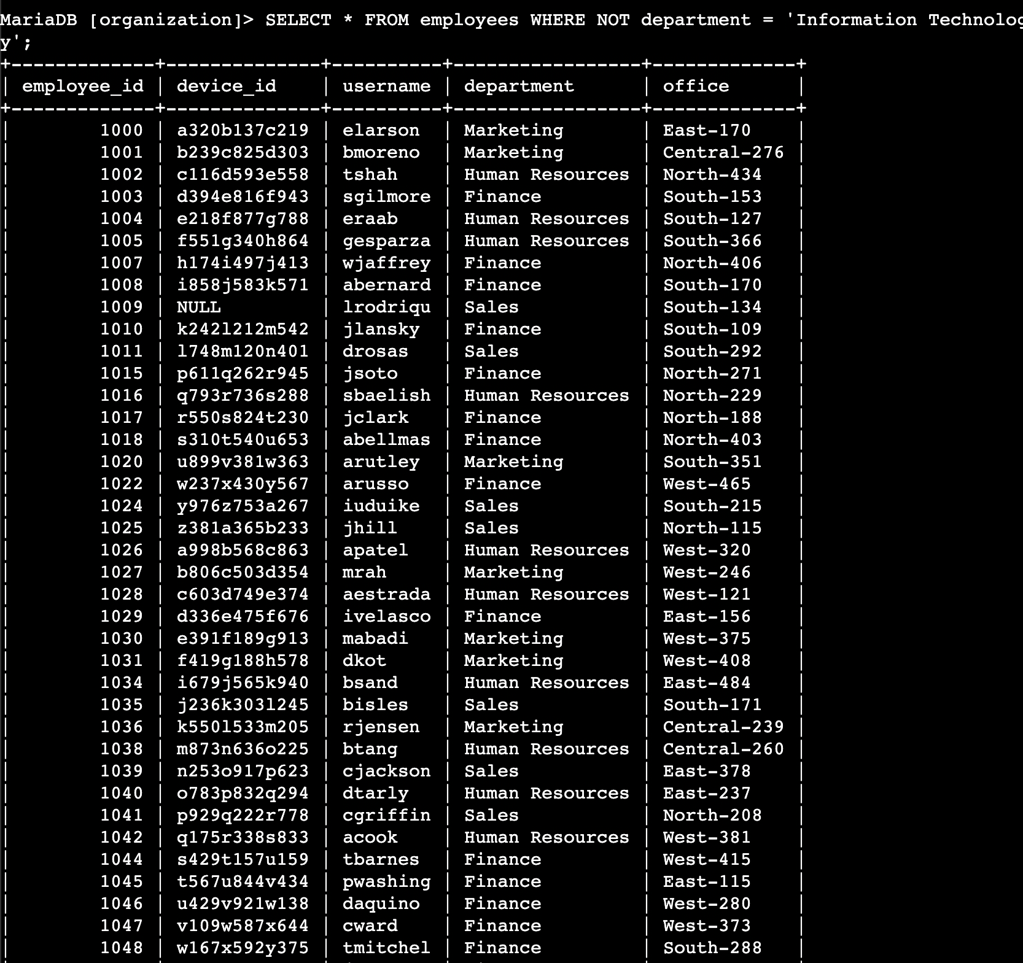

To exclude the IT department employees, a query using NOT is performed, resulting in 161-row table, all of which cannot be represented here.

## Summary

For this assignment, some SQL queries were performed to teach the usage of keywords AND, OR, NOT, and LIKE.